What is Event Sourcing?
In traditional software development (CRUD-based systems), applications store the current state of an entity in a database. If a user updates their email address, the old email is overwritten, and history is lost unless explicitly logged.
Event Sourcing takes a fundamentally different approach. Instead of storing just the current state, the application stores every state-changing event as a sequence of immutable records in an Event Store.
- The Event Store: An append-only log of all events that have ever occurred (e.g., AccountCreated, MoneyDeposited, MoneyWithdrawn).
- Current State Derivation: The current state of an object is calculated by replaying all its historical events from the beginning.
- Immutability: Events cannot be updated or deleted; corrections are made by appending compensating events (e.g., PaymentRefunded).

Core Components of Event Sourcing
- Commands: Intentions from the user to change state (e.g., DepositMoneyCommand).
- Events: Facts that have happened in the past (e.g., MoneyDepositedEvent).
- Event Store: The specialized database optimized for appending and reading event streams.
- Aggregates: Domain objects that process commands, apply business logic, and generate events.
- Projections / Read Models: Materialized views built by listening to events, optimized specifically for fast querying (frequently paired with CQRS — Command Query Responsibility Segregation).

Key Use Cases
Event Sourcing shines in complex domains where data integrity, history, and scalability are paramount:
- Financial & Banking Systems: Every transaction must be tracked with absolute precision. A balance is never just a number in a table; it is the sum of all past credits and debits, providing a built-in audit trail.
- Audit & Compliance Heavy Industries: Healthcare, legal, and government systems where regulatory compliance mandates tracking who did what and when.
- Collaborative Real-Time Applications: Systems like document editors or project management tools (e.g., Trello or Google Docs) where tracking user action sequences helps resolve conflicts and implement "undo/redo" features.
- Microservices Architecture: Event-driven microservices use event sourcing to communicate changes reliably across services using message brokers (like Kafka or RabbitMQ).

Implementing Event Sourcing in a Java Spring Boot Application

Pros and Cons Summary
Advantages | Disadvantages
Complete Audit Trail: Perfect history of every state change for debugging and compliance. | Steeper Learning Curve: Concepts like eventual consistency and CQRS add complexity.
Time Travel Debugging: Ability to reconstruct state at any exact point in time. | Data Evolution/Versioning: Changing event structures over time requires upcasters or migration strategies.
High Write Performance: Append-only logs are significantly faster than relational updates. | Eventual Consistency: Read models might lag slightly behind write operations.
To understand how Event Sourcing works under the hood without getting overwhelmed by heavy frameworks, here is a simple, self-contained Spring Boot example using a Bank Account domain.
In this project, instead of updating a balance column in a database table, we store every transaction as an event in an EventStore and rebuild the account's balance by replaying

Here is how you can integrate Spring’s ApplicationEventPublisher and @EventListener into your Bank Account Event Sourcing project structure.
In this flow, whenever an event is saved to the EventStoreService, it is published as a Spring application event. An @EventListener method automatically catches it to perform secondary tasks (like logging, sending notifications, or updating a read model) without cluttering the business logic.

File Structure
Plaintext
src/main/java/com/example/eventsourcing
│
├── controller/
│ └── AccountController.java
├── domain/
│ └── BankAccountAggregate.java
├── event/
│ ├── Event.java
│ ├── AccountCreatedEvent.java
│ └── MoneyDepositedEvent.java
└── service/
└── EventStoreService.java

Step 1: The Event Classes (event/)

event/Event.java
Java
package com.example.eventsourcing.event;

public interface Event {
String getAggregateId();
}

event/AccountCreatedEvent.java
Java
package com.example.eventsourcing.event;

public class AccountCreatedEvent implements Event {
private final String accountId;
private final String owner;

public AccountCreatedEvent(String accountId, String owner) {
this.accountId = accountId;
this.owner = owner;
}

@Override public String getAggregateId() { return accountId; }
public String getOwner() { return owner; }
}

event/MoneyDepositedEvent.java
Java
package com.example.eventsourcing.event;

public class MoneyDepositedEvent implements Event {
private final String accountId;
private final double amount;

public MoneyDepositedEvent(String accountId, double amount) {
this.accountId = accountId;
this.amount = amount;
}

@Override public String getAggregateId() { return accountId; }
public double getAmount() { return amount; }
}

Step 2: The Event Store Service with Publisher & Listener (service/)
Here, EventStoreService injects Spring's ApplicationEventPublisher to broadcast events, and contains an @EventListener method that automatically triggers when any event is saved.
Java
package com.example.eventsourcing.service;

import com.example.eventsourcing.event.Event;
import org.springframework.context.ApplicationEventPublisher;
import org.springframework.context.event.EventListener;
import org.springframework.stereotype.Service;

import java.util.*;

@Service
public class EventStoreService {

// Simulating an append-only database table
private final Map<String, List<Event>> store = new HashMap<>();

// Spring's built-in publisher
private final ApplicationEventPublisher eventPublisher;

public EventStoreService(ApplicationEventPublisher eventPublisher) {
this.eventPublisher = eventPublisher;
}

public void save(String aggregateId, Event event) {
// 1. Save to the event store
store.computeIfAbsent(aggregateId, k -> new ArrayList<>()).add(event);

// 2. Publish the event so Spring @EventListeners can catch it
eventPublisher.publishEvent(event);
}

public List<Event> getEventsForAggregate(String aggregateId) {
return store.getOrDefault(aggregateId, Collections.emptyList());
}

// --- SPRING @EVENTLISTENER ---
// This method automatically runs whenever eventPublisher.publishEvent() is called
@EventListener
public void handleDomainEvent(Event event) {
System.out.println("--------------------------------------------------");
System.out.println("📢 [SPRING @EventListener TRIGGERED]");
System.out.println(" Event Type: " + event.getClass().getSimpleName());
System.out.println(" Aggregate ID: " + event.getAggregateId());
System.out.println("--------------------------------------------------");
// Here you could update a read-model database, send an email, or log for auditing
}
}

Step 3: The Aggregate (domain/)
Java
package com.example.eventsourcing.domain;

import com.example.eventsourcing.event.*;
import com.example.eventsourcing.service.EventStoreService;

import java.util.List;

public class BankAccountAggregate {
private String accountId;
private double balance;
private boolean active;

// Rebuild state by replaying historical events
public BankAccountAggregate(List<Event> history) {
for (Event event : history) {
applyEvent(event);
}
}

private void applyEvent(Event event) {
if (event instanceof AccountCreatedEvent) {
this.accountId = ((AccountCreatedEvent) event).getAggregateId();
this.active = true;
this.balance = 0.0;
} else if (event instanceof MoneyDepositedEvent) {
this.balance += ((MoneyDepositedEvent) event).getAmount();
}
}

// Command: Create Account
public static void createAccount(String accountId, String owner, EventStoreService eventStore) {
Event event = new AccountCreatedEvent(accountId, owner);
eventStore.save(accountId, event); // This triggers saving + event publishing
}

// Command: Deposit Money
public void deposit(double amount, EventStoreService eventStore) {
if (!active) throw new IllegalStateException("Account is not active");
if (amount <= 0) throw new IllegalArgumentException("Deposit must be greater than zero");

Event event = new MoneyDepositedEvent(this.accountId, amount);
eventStore.save(this.accountId, event); // This triggers saving + event publishing
applyEvent(event);
}

public double getBalance() { return balance; }
}

Step 4: The Controller (controller/)
Java
package com.example.eventsourcing.controller;

import com.example.eventsourcing.domain.BankAccountAggregate;
import com.example.eventsourcing.event.Event;
import com.example.eventsourcing.service.EventStoreService;
import org.springframework.web.bind.annotation.*;

import java.util.List;
import java.util.UUID;

@RestController
@RequestMapping("/accounts")
public class AccountController {

private final EventStoreService eventStoreService;

public AccountController(EventStoreService eventStoreService) {
this.eventStoreService = eventStoreService;
}

@PostMapping
public String createAccount(@RequestParam String owner) {
String accountId = UUID.randomUUID().toString();
BankAccountAggregate.createAccount(accountId, owner, eventStoreService);
return "Account created with ID: " + accountId;
}

@PostMapping("/{id}/deposit")
public String deposit(@PathVariable String id, @RequestParam double amount) {
List<Event> history = eventStoreService.getEventsForAggregate(id);
BankAccountAggregate account = new BankAccountAggregate(history);

account.deposit(amount, eventStoreService);

return "Deposited " + amount + ". New Balance: " + account.getBalance();
}

@GetMapping("/{id}/balance")
public double getBalance(@PathVariable String id) {
List<Event> history = eventStoreService.getEventsForAggregate(id);
BankAccountAggregate account = new BankAccountAggregate(history);
return account.getBalance();
}
}

What happens when you test this?
When you make a request to deposit money (POST /accounts/{id}/deposit?amount=100), check your IDE console. You will see:
Plaintext
--------------------------------------------------
📢 [SPRING @EventListener TRIGGERED]
Event Type: MoneyDepositedEvent
Aggregate ID: a1b2c3d4-e5f6...
--------------------------------------------------

In event sourcing we take events as source of truth.

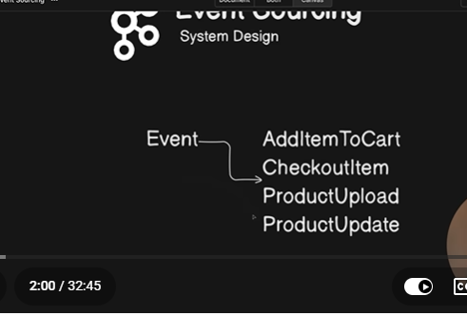

Lets suppose if a normal use do a transaction its directly saved in the database.
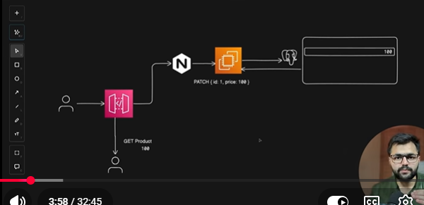
Comparing normal data storage (CRUD / In-place updates) with Event Sourcing comes down to trade-offs between simplicity and power.
Here is a breakdown of the key benefits of Event Sourcing over normal data storage:

1. The Core Comparison at a Glance
Feature | Normal Data Storage (CRUD) | Event Sourcing
What is stored? | The current state only (e.g., balance = 150). | The history of all changes (e.g., +100, then +50).
Updates | Overwrites existing rows (UPDATE accounts SET balance = 150). | Appends new immutable events to a log.
Audit Trail | Difficult (requires extra audit tables, triggers, or logs). | Automatic & 100% reliable (the event log is the audit trail).
Complexity | Low. Easy to learn, write, and query. | High. Requires rebuilding state, CQRS, and eventual consistency.

2. Key Benefits of Event Sourcing

🛡️ 1. Bulletproof Audit Trail & Compliance
- Normal Storage: If a user disputes a transaction or an error occurs in a financial app, finding out who changed what and when requires complex database logs or separate audit tables.
- Event Sourcing: Every single action is recorded as a permanent, immutable fact. You have a built-in historical record that satisfies strict regulatory compliance (banking, healthcare, legal) effortlessly.

⏪ 2. "Time Travel" Debugging & State Reconstruction
- Normal Storage: You only know the present. If data gets corrupted, it's hard to trace back how it happened.
- Event Sourcing: Because the current state is just a result of replaying events, you can "travel back in time" and inspect what the exact state of an entity was at any given timestamp or event sequence. This makes debugging production bugs exceptionally easy.

🔄 3. Complete Flexibility in Read Models (CQRS)
- Normal Storage: Your database schema is usually optimized around how data is entered (written), which often makes complex reporting or UI queries slow or awkward.
- Event Sourcing: Because events are broadcasted (like using @EventListener), you can spin up multiple Read Models (projections). One event stream can update a PostgreSQL database for web dashboards, a MongoDB store for user profiles, and an Elasticsearch index for search—all simultaneously, without touching the core write logic.

🚀 4. High Write Performance
- Normal Storage: Relational updates (UPDATE / DELETE) require database locks, index updates, and row shuffling, which can bottleneck high-throughput systems.
- Event Sourcing: Writing data is purely an append-only operation. Appending to the end of a log file or table is one of the fastest database operations possible, allowing systems to handle massive traffic spikes.

↩️ 5. Built-in "Undo / Redo" Capabilities
- Normal Storage: Implementing an "Undo" feature requires writing custom reverse-logic for every single action in your app.
- Event Sourcing: Since history is preserved, implementing features like "Undo last action" is as simple as ignoring the last event or applying a compensating event.

Summary: When should you use which?
- Use Normal CRUD Storage for 90% of standard web applications, CRUD portals, blogs, simple e-commerce sites, and MVPs where development speed and simplicity matter most.
- Use Event Sourcing for complex domains where history, auditability, financial accuracy, or high concurrency are critical (e.g., banking systems, inventory tracking, collaborative tools, and complex microservices).

In thi
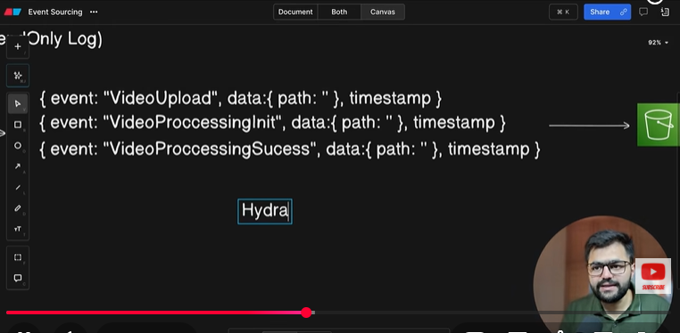

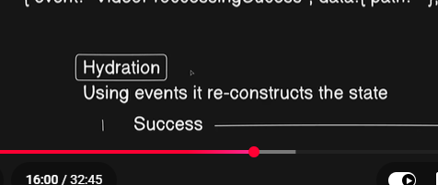
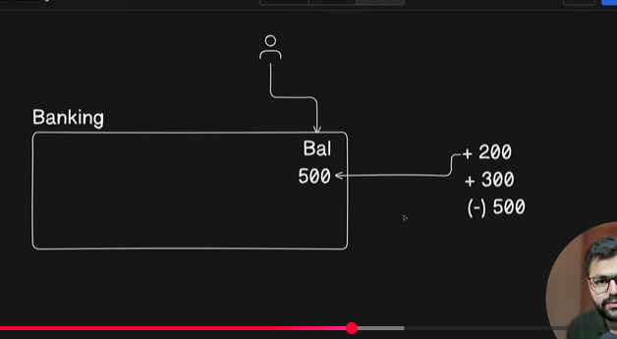
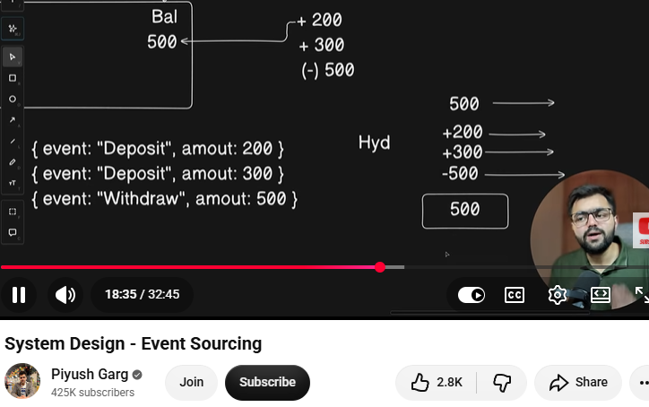
Hydration - using events it reconstructs the state.
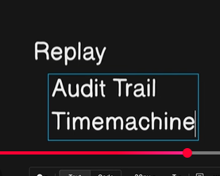
when its goes wrong then we can check the state again.
reconciliation = replay
